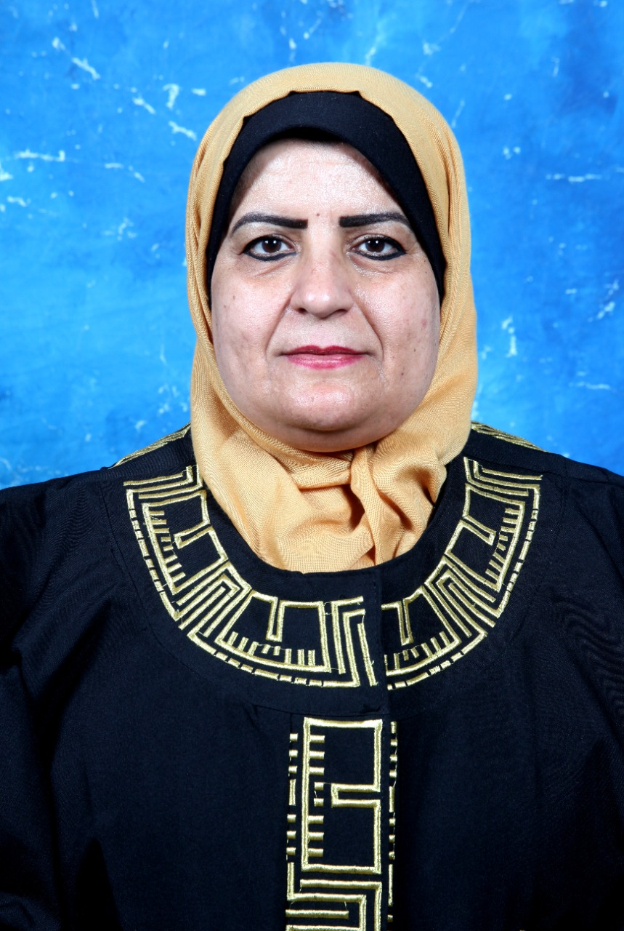
Instructor Name: Insaf Ali Shaban

Insaf A. Shaban, DMid, RN; RM
Associate Professor.
Midwifery: Major
Maternal and Child Health Department
Al Albayt University
Amman 11941 Jordan
PO Box 2676
(+962)-79-7870101
Email: dr.shaban@aabu.edu.jo

DEGREES:
Doctor of Midwifery (DMid), 2006
The University of Technology, Sydney (UTS) - School of Nursing and Midwifery, Sydney, Australia
M. Sc. in Nursing Education, 1999
University of Jordan, Amman, Jordan
Postgraduate Higher Diploma Certificate in Midwifery, 1998
Princess Muna College of Nursing/ Royal Medical Services
BSc. in General Nursing, 1993
University of Jordan, Amman, Jordan

ACADEMIC EXPERIENCE:
Vice Dean for Quality Assurance, Al albayt University, Princess Salma Faculty of Nursing-Jordan, Mafraq 2021 – at present
Vice-Dean for Postgraduate Studies & Scientific Research at Taibah University, College of Nursing, Madinah Munawara, KSA 2019-2021
Assistant to the Vice-Dean for Academic affair at Taibah University, College of Nursing, Madinah Munawara, KSA 2016-2018
Acting Dean at Al albayt University, Princess Salma Faculty of Nursing, Jordan-Mafraq 2006-2009
Chairman, Maternal & Child Health Department, Al albayt University, Princess Faculty of Nursing, Jordan-Mafraq 2008-2012
Teaching Nursing Courses, Al albayt University, Princess Salma Faculty of Nursing, Jordan-Mafraq 2001-present
Thesis Supervision & Thesis Jury members for several Master students
Associate Professor; 2014-present
Assistant Professor; 2006

NON- ACADEMIC EXPERIENCE:
2017-present  Member in Midwifery Scientific Council Committees at Saudi Commission for Health Specialties (SCFHS)

2016 Member in Midwifery Steering Committee at SMOH to work in developing midwifery as a profession in the Saudi Arabia.

2015 Represents the faculty of nursing in a working group selected from faculty of nursing at Taibah University to develop a master program in Maternal Health Nursing.

2014-present Reviewer for many Journals as : Midwifery Journal; Nurse Education Today (NET); Journal of Transcultural Nursing (JTN); International Journal of Nursing and Medwifrey (IJNM); and, Journal of Taibah University Medical Sciences (JTUMS)

2012-present Consultancy position at Accreditation and Quality Assurance Commission (AQAC) –Ministry of Higher Education- State of Palestine –To review several programs in nursing and midwifery education.

2014 HRH Consultant at Abt Associates Inc –USAID-HSS2- To develop Midwifery Ladder clinical scale at MOH-JORDAN

2013 until now Rater for the McMaster Online rating of evidence (More) system offered through the health information research unit of McMaster University.

2012-2013 The chief of the scientific research committee, Prince Salma Nursing faculty, Al al-Bayt University, Jordan.

1999-2001 Head Nurse /Obstetric and Gynecological Theater, MOH, Al Basheer Hospital, Amman-Jordan

1991-1999Staff Nurse – Theater Nurse, Maternal Word, MOH, Al Basheer Hospital, Amman-Jordan

CERTIFICATE OR PROFESSIONAL REGISTRATIONS:
Jordanian Nursing Midwifery Council (JNMC)
Jordanian Nursing Council (JNC)
Saudi Commission for Health Specialties (SCFHS)

PUBLICATIONS FOR THE PAST FIVE YEARS:

Alsehimi, O.; Shaban, I. (2021) Exploring Maternity Healthcare Providers’ Perspectives on Maternal Upright Positions during Second Stage of Labor: Qualitative Study.EJH_2021_12(4) _233-247
Altaweli, R.; Shaban, I.; Paine, P. (2020) Report on the midwifery workforce in the MOH, Saudi Arabia for 2019. Practicing midwife. 23 (8), 25-30
Aljohani, M.; Tubaishat, A.; Shaban, I. (2019) The Effect of Simulation Experience on Saudi Nursing Students' Advance Cardiac Life Support Knowledge. IJANS_2019_11_100172 https://doi.org/10.1016/j.ijans.2019.100172
Mohammed, K; Shaban, I.; Al-Akour, N.; Kassab, M. & Creedy, D. (2019): Low birth weight in Jordan: a hospital-based study, The Journal of Maternal-Fetal & Neonatal Medicine, DOI: 10.1080/14767058.2019.1567707
Shaban, I., Al-awamreh, K , Mohammad, K Gharaibeh, H. (2018) Postnatal women’s perspectives on the feasibility of introducing postpartum home visits: a Jordanian study. Home Health Care Services Quarterly. ISSN: 0162-1424
Aloush, S., Abdelkader, F., Al-Sayaghi, K., Tawalbeh, L., Suliman, M., Al Bashtawy, M., Shaban, I. (2017) Compliance of Nurses and Hospitals with Ventilator-Associated Pneumonia Prevention Guidelines: A Middle Eastern Survey. J Nurs Care Qual. 2017 Aug 24. doi: 10.1097/NCQ.0000000000000286
Mohammad, K.; Kassab, M.; Shaban, I.; Creedy, D.; Gamble, J. (2017) Postpartum Screening of Vitamin D levels among Jordanian Women. Journal of Obstetrics & Gynaecology. 37 (2).200-204.
Shaban, I., Shlash, K., & Homer, C. (2016). Development and Validation of Women's Satisfaction with hospital-based intrapartum care scale in Jordan. J Transcult Nurs 27 (3); 256-61
Kassab, M.; Shaban, I.; Mohammad, K.; Creedy, D. (2016) Prevalence of Hypovitaminosis D among Jordanian Healthy Infants: A Descriptive Cross Sectional Study. Journal of Pediatric Nursing. 31(2); 119-125

WORKSHOP; INTERNATIONAL CONFERENCES AND PRESENTATIONS FOR THE PAST FIVE YEARS:
6Th Annual MENA Women Health Virtual Congress, 25-27 February 2021, organized by Maarefah Management.

5th Annual General Meeting of the Saudi Midwifery Group-International Virtual Conference, 27-28 November 2020

Item Author Certification Program-Phase 1Workshop. SCFHS, Jeddah, Saudi Arabia, November 15, 2018

AMANI Birth: 21-hour Childbirth Educator & Doula Training Workshop, March, 23-25, 2017, Khobar, Saudi Arabia.

CME/PD activity entitled “21st Perineal Trauma Course & Workshop”, Intercontinental Hotel, Jeddah, Saudi Arabia, February 24, 2017.

Simulation Instructor Education & Training: Workshop for novice and beginners, February 22-23, 2017, College of Nursing, Taibah University-Madinah Munawara.

Medical Error. Patient Safety Symposium, December 26-27, 2016, College of Nursing-Taibah University-Madinah Munawara.

Courses Taught:
MSN: Maternal Health Nursing Program-
- Women’s Health Course (Academic year 2020-2021-Second Semester)

- Advanced Labor and Delivery Course (Academic year 2020-2021-First Semester)

- Applied Pharmacology in Maternity Care Course (Academic year 2019-2020-Second Semester)

- Nursing Research Methodology Course (Academic year 2019-2020-First Semester)

- Research Project Course (Academic year 2020-2021-Second Semester)

BSc: Nursing Program-

- Research Methods in Nursing (Academic year 2006-2007-Second Semester-One section of 55 students)

- Nursing Leadership and Management- Theory (Academic year 2007-2008-First semester- One section of 47 students);

- Maternal Health Nursing- Theory (Academic year 2005-2006-Second semester- One section of 69 students); (Academic year 2006-2007- First semester-One section of 62 students- Second semester-One section of 103 students); (Academic year 2007-2008- First semester-One section of 48 students Second semester-One section of 66 students and second section for 56 students);(Academic year 2008-2009-First semester-One section of 60 students, second section of 46 students; Second semester-One section of 78 and second section of 81 students);

- Maternal Health Nursing- Clinical (Academic year 2006-2007-First semester- One section of 18 students and second section of20 students);

- Theater Nursing and Infection Prevention- Clinical (Academic year 2006-2007-First semester- 2 section each have 20 students);

- Neonatal Health Nursing (Academic year 2005-2006-Second semester-One section of 40 students); (Academic year 2006-2007-Second semester-One section of 30 students).

- Fundamental of Nursing (Academic year 2008-2009-Second semester-One section of 61 students).

TRANSLATING BOOK

د. رؤى الطولي، د. انصاف شعبان، هيا العجلوني (2021) هذا جسمي وهذا طفلي. دار حنان صلواتي للنشر والتوزيع. رقم الايداع 842/1442. المملكة العربية السعودية

HONORS/AWARDS
- Full scholarship/PHD degree in nursing, Al al-Bayt University, Jordan.
- Full scholarship/higher diploma degree in Midwifery, Ministry of Health, Jordan.

RECENT PROFESSIONAL DEVELOPMENT ACTIVITIES
▪ Reviewer at many International Journals.
▪ Chairperson for the administration of quality assurance, Faculty of nursing, Al al-Bayt university
▪ External examiner for Master nursing theses at JUST.

