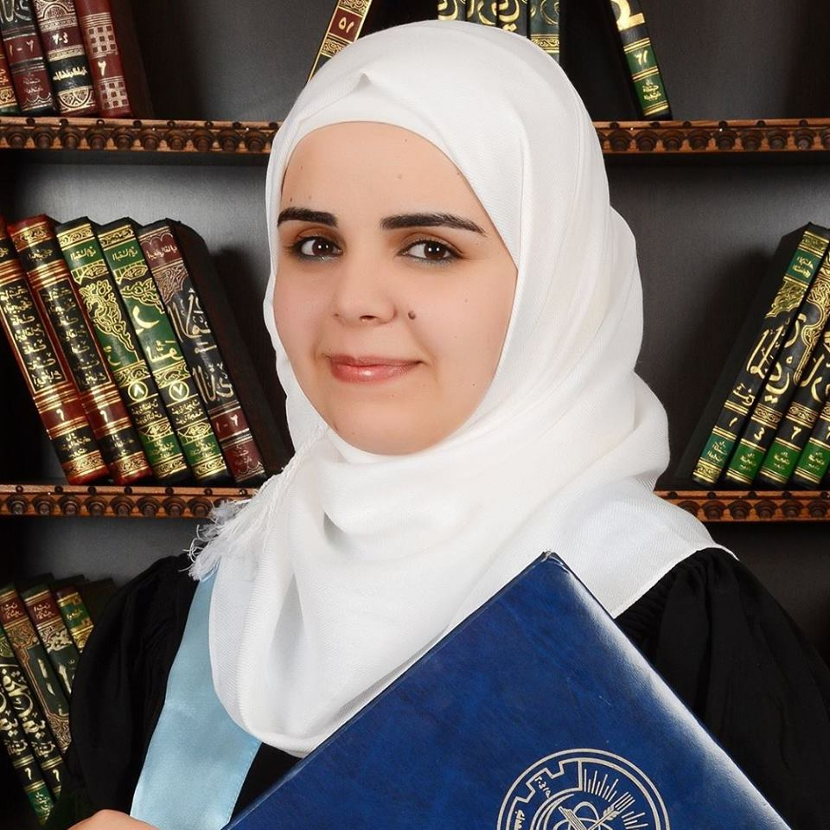
Fatima Mahmoud Bani Salama
Tel: 0777945469
E-mail: fmj_171@yahoo.com
https://www.facebook.com/fatima.banisalama
PERSONAL INFORMATION
Date of Birth | Gender | Marital status | Nationality
17/1/1987 | Female | Single | Jordanian

EDUCATION
Degree | Institution | Year of Graduation | Major | Average | Rank
Master in clinical pharmacy | Jordan University of Science and Technology | 2014/2015 | Clinical Pharmacy | 83.2% | Very Good
Bachelor in Pharmacy | Jordan University of Science and Technology | 2001/2012 | Pharmacy | 87.5% | Excellent
General secondary School certificate | Al ashrafia Secondary School – Irbid | 2005 | Scientific stream | 92.2% | Excellent

TRAINING
Conference | Run by | Place | Date
2nd Conference | Jordan Pharmacists Association | Amman Private University | 7/7/2012
AUS-Pharmacy First National Conference "Recent Trends in postgraduate Research" | Applied Science Private University | Applied Science Private University | 20-21/12/2014

EXPERIENCE
Job | Place | From | To
Staff Pharmacist | Al Razi Pharmacy , Irbid | 2010 | 2014
Part time Lecturer | Jordan University of Science and Technology | 14-9-2014 | 23-1-2015
Full-time Lecturer | Al al-Bayt University | 1/2/2015 | present

SKILLS
Type |  | Description
Language Knowledge | Arabic (Native Language) | Fluent in speaking and excellent in writing
Language Knowledge | English (Foreign Language) | Fluent in speaking and excellent in writing
- Excellent experience in Microsoft Office products (Word, Excel, Power Point and MS project) .
- Experience installing, configuring and troubleshooting windows.
- Internet skills and search.
- Bilingual, Intelligent and Dynamic Person.
- Able to build long lasting business relationship with others based on trust, integrity, transparency and service excellence.
- Ability to prioritize workload and handle multiple tasks simultaneously.
- Aptitude for learning and impacting business processes and systems.
- Ability to use creative thinking on the job, including problem solving and business decision-making.
- Solid team skills.
- Consistent initiative, organization, and flexibility.
- Demonstrated ability to deliver results in undefined situations or changing environments.
- Use of negotiation and influence skills to achieve project objectives.
- Proven ability to establish, lead and maintain strong working relationships with team and business partners.

- Driving License
Jordanian driving license
REFERENCE
Name | Job | Contact
Name | Job | Phone number | E-mail
Prof. Karem Al-Zoubi | Vice dean, Department of Clinical Pharmacy at JUST | 0799908536 | Khalzoubi@just.edu.jo
Dr. Nizar Mhaidat | Dean, Faculty of Pharmaceutical Sciences at Hashemite University | 0772215374 | nizarm@hu.edu.jo  nizarm@just.edu.jo
Dr. Khalid Hadad | Al-Razi pharmacies manager | 0795548154 | -

