Curriculum Vitae

PERSONAL INFORMATION
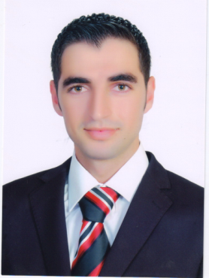
Name: BASHAR A. SHBOUL

Position: Thermal Power-Mechanical and Renewable Energy Engineer.

Sex: Male
Place and date of Birth: Irbid – Jordan. April 2, 1988
Nationality: Jordanian

Marital Status: Single

Address: Ramtha, Jordan

E-mail: b.shboul@aabu.edu.jo

Skype username: bash.shboul16

EDUCATION

M.Sc. in Engineering of Renewable Energy and Sustainable Development, Jordan University of Science and Technology, Irbid, Jordan, 2015.
Thesis title: Improving the energy efficiency of residential buildings in Irbid.
B.Sc. in Mechanical Engineering, Jordan University of Science and Technology, Irbid, Jordan, 2011
Graduation Project title: Electricity of Dental Clinic Building from Photovoltaic Cell.

The General Secondary Educated Certificate Examination (GSECE), 2006, Jordan

PROFESSIONAL EXPERIENCE

Mar. 2012-Jan.2014
Teacher Assistant at the Mechanical and Aeronautical Engineering Department, Jordan University of Science and Technology, Jordan
Oct 2014- May 2015
Lab-Supervisor at the Department of Mechanical and Industrial Engineering, Applied Science University, Jordan
Oct 2015- up to now
Full-Time Lecturer at the Renewable Energy Engineering Department, AL al-Bayt University, Jordan
VOLUNTEER WORKS

Teacher of physics at primary school for Syrian refugee students

PROFESSIONAL MEMBERSHIPS

- Jordan Engineers Association (JEA)
- Jordanian Renewable Energy Society (JRES)
- Jordan Green building council (GBC)

Jordan Environment Society (JES)

COURSES TAUGHT

- Courses:

- Introduction to Renewable Energy
- Thermodynamics (1 & 2)
- Fluid Mechanics
- Applied Mathematics for Engineers
- Engineering Drawing
- Engineering Workshop
- Statics
- Dynamics
- Vibrations
- Plumbing System

- Laboratories:

- Heat Transfer Lab
- Thermodynamic Lab
- Internal Combustion Lab
- Strength of Material Lab
- Renewable Energy Lab
- Fluid and Hydraulic Lab

Language Skills

- Mother tongue(s) : Arabic

- Other languages

Language | Understanding |  | Speaking |  | Writing
 | Listening | reading | spoken interaction | spoken production
English | C1 | C1 | C1 | C1 | C1
French (DELF A2) | A2 | A2 | A2 | A2 | A2
Spanish | A2 | A2 | A2 | A2 | A2
Levels: A1/A2: Basic user - B1/B2: Independent user - C1/C2: Proficient user
Common European Framework of Reference for Language

ADDITIONAL INFORMATION
References available upon request

