Curriculum Vitae

personal information 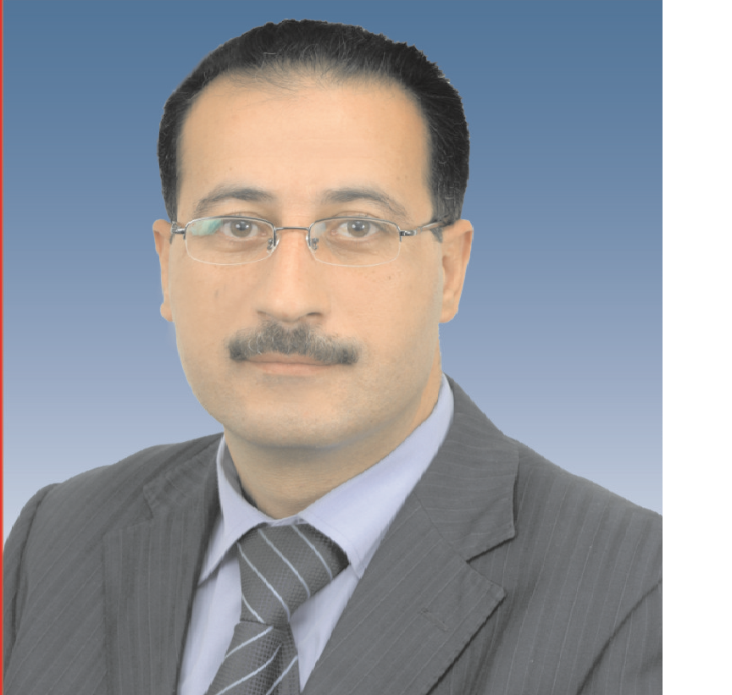
Name Omar Mahmoud Said AL-Ajlouni
Gender male
Date of Birth 02\18\1970
Place of Birth Irbid
Nationality Jordanian
Address Mafraq
Cell phone (0775475801)
Email omar_ajlouni@yahoo.com
Marital status married

Education \Qualifications:
1987-1992 Bachelor of Computer seines \Yarmouk University \ Jordan\Irbid

Work Experiences:
2007- Today Director of Career Counseling Office \ King Abdullah II Fund for Development \ Al al-Bayt University
2001-2006 Supervisor of computer lab \Computer Center \ Al al-Bayt University
1997-2001 Purchases Employee \Supplies Department \ Al al-Bayt University
1994-1997 Administrative Employee \Supplies Department \ Al al-Bayt University
1992-1994 Head of Programming Division \ Ministry of Public Works and Housing

Training Courses:
1-3/12/2016 Workshop of “Preparation of Business Plans” Leading Point Management Advisory Services, Jordan \ Amman
29-31\5\2016 “Forus” Gate & vocational guidance “Tmheed” Training\ Jordan \ Amman
20-22 \ 3\2016 Advanced workshop of Career Guidance "my future career," IYF \ Jordan \ Amman
17-18 \ 8\2015 Workshop of Career Guidance "my future career," IYF \ Jordan \ Amman
1-30 \ 10\2014 Training Course of Leadership Skills and Civic Participation \ YWCA
2014 First Aid and CPR Training \Jordan Paramedic Society \ Jordan
2014 workshop of Friends of Environment \ Jordan Society for Environment Protection \ Jordan
12-13 \ 12\2012 Conference of Local Partners \ Peace Corps \ Jordan \Amman
21\10\2011-3\1\2012 The Pre-Service Training \ Peace Corps \ Jordan
6-12 \ 9\2011 Service Learning and Civic Engagement Study Lour 2011 \Roehampton University \ London
8-16 \ 6\2010 Service Learning and Civic Engagement Study Lour 2010 \NUI Galway \ Ireland
29-30 \ 9\2011 Strategic Planning and Strategic Thinking, Advanced Workshop \Creativity Center Amman \ Jordan
1-6 \ 6\2008 Management and Marketing Training Course\ Business Development Center\ Amman \ Jordan
30\12 \2007-27\1\2008 Senior management skills, Al al-Bayt University \ Jordan
26\8\2007 Workshop “Strengthening is the Correction Path for the Human Investment”\ Arabic for Scientific Media Amman \ Jordan
8\7\2007 -22\7\2007 Middle Management Skills\ Al al-Bayt University \ Jordan
2007 Journalism Writing Skills\ The Center for Defending Freedom of Journalists \ Jordan

Membership & Activities:
2016 Career Guidance Certified Trainer "IYF"
2016 Organizer of "National Industries Exhibition"
2016 Supervisor of "Education for Employment" Program
2016 Supervisor of "Ambassadors for Dialogue" Program in cooperation with the Danish Youth Council
2014 Supervisor & Designer Al al-Bayt University Application Mobile
2013 Participation in the review of Peace Corps programs in Jordan
2013 Brainstorming session “Career Guidance”\ Jordan\Amman
2012-2016 Supervisor "DARB Program" Training and employment of students in institutions and companies
2013-2016 Contact Person, "Ana Usharek" & "Ana Usharek+ Program", US National Democratic Institute, for political development for young students , Al al-Bayt University
2012-2014 Member of the administrative body of the Workers club \ Al al-Bayt University
2008-2016 Organizer "Career Days"
2007-2016 Organization and management a large number of human development courses
2007-2016 Supervisor: INJAZ Program\ Al al-Bayt University
2011-2013 A certified Instructor\ INJAZ Foundation
2010-2013 Contact Person, Training of the US Peace Corps \ Al al-Bayt University
2010 Member of the Commission follow-up “Service Learning and Civic Engagement” Project
2008-2011 Contact Person, "Maharat Program"\ Business Development Center BDC
2009 Contact Person, Follow-up of the Strategic Plan for Traffic Safety \MOHE
2009 Supervisor of "Princeton University delegation's visit to Al al-Bayt University"
2009 Contact Person, Agreement of Royal Health Awareness Society
1996-1998 Member of the administrative body of Association staff \ Al al-Bayt University
1997 The Founder of Essarih Society Cooperative\Essarih - Irbid

Initiatives:
2012 English Club Initiative
2012 French Club Initiative
2012 Creative thinking Club Initiative
2010 “Today Reader Tomorrow Leader” Project
2007 “From student to student” Project

Voluntary Work:
2012-2013 “Juthoor” program
2012 Cleaning Day in Bala’ama \ Mafraq
2012 Planting a Garden in Mafraq School

Letter of Thanks:
19/5/2016 Dean of Students Affairs\ Al al-Bayt University
20/4/2015 Ministry of Labor
28/10/2013 Peace Corps
8/4/2013 The President \ Al al-Bayt University
24/3/2013 Dean of Students Affairs\ Al al-Bayt University
15/1/2013 Dean of Students Affairs\ Al al-Bayt University
10/9/2012 INJAZ
30/7/2009 INJAZ
22/5/209 KAFD
11/7/1998 The President \ Al al-Bayt University

Personal Skills:
High communication skills
Capacity to leading the team
Work under pressure
Ability to make decisions

Computer Skills:
Good Knowledge of MS Word, MS Excel, MS PowerPoint

Interests:
Travelling, Voluntary Work, Swimming, Fitness, playing Chess,

