CURRICULUM VITAE

A.PERSONAL DATA:

Name: Zain Q. AL Momani
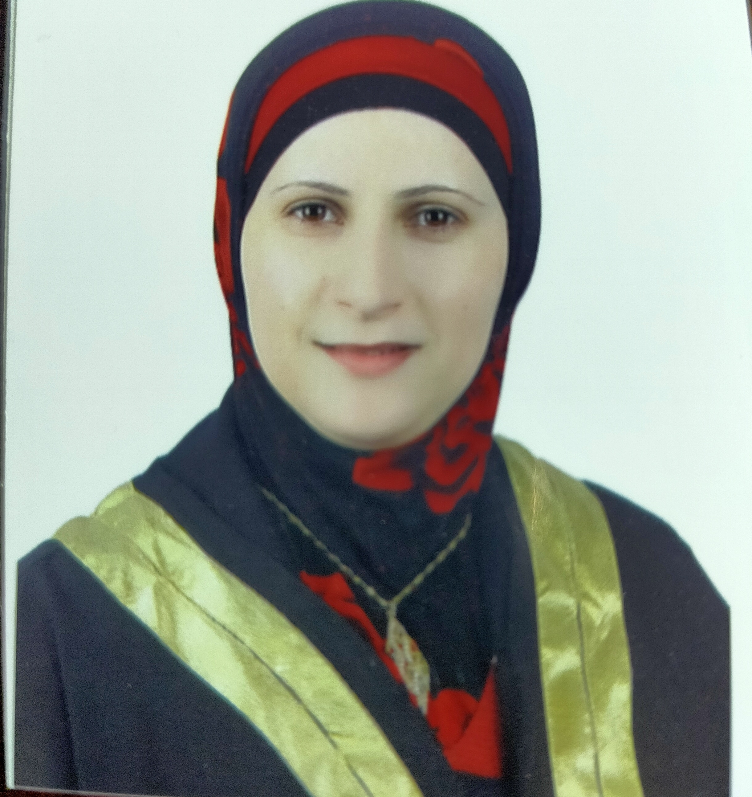

Place/Date of birth: Ajlun, July 1975.
Sex: Female.
Marital Status: Married.
Religion: Moslem.
Nationality: Jordanian.
Permanent Address: Tabarbor, Amman - Jordan.
Contact Number:

Mobile 00962-790192943
E-Mail: zainmomani@yahoo.com
momani2723@aabu.edu.jo

B. RECENT PROFILE

Education

BSN: Jordan University of Science and Technology, June 1997, Irbid, Jordan.

MSN: Jordan University of Science and Technology, 2006, Irbid, Jordan.

